University Of Oklahoma
School of Aerospace and Mechanical Engineering
AME4163: PRINCIPLES OF DESIGN

FALL 2002

Assignment 1: Team Prospectus and Project Schedule

Now that you have formed your design team for AME4163 it is time to develop a prospectus of the team, which will highlight the strength, weakness, and mode of operation for the your design team. Also as a design team plan activities related to the WWF project for the first half of the semester.

Team Prospectus
- Resume of Individual Team members: Each member of the team should prepare his/her individual resume.
- Skills, experiences and strengths of the team: Using the resumes, as a team, categorize the skills and experiences of the members.
- Team contract: As a team discuss expectations of each member of the team with the other members. From this set of expectations write a short contract among the team members. Everyone should sign the contract. The contract should highlight team organization and governance: How will you structure your team? Who will be responsible for what? How will you resolve differences? What are the ground rules with respect to meeting times, tardiness, poor work, and conflict resolution? What is the guiding philosophy for designing for this group? For example, design using available assets? etc.

Project Schedule
Chapter 4 of the textbook highlights the steps involved in the design process. Use of DSPT icons to design the design process was also presented in class. Using these information to develop a project schedule for the entire semester.
- PEI Diagram. Draw the PEI diagram and explain its contents. Relating the Phases, Events and Tasks to various dates along the time-line.
- Events & Tasks:
This is a crucial step for the overall success of the project in general and directly influences the amount of time you will end up spending on the project. Planning will be the key to how much time you will have for testing the system before the competition. Hence, this activity and should be taken very seriously. For each event in the PEI diagram state the objective and Personnel requirements (Step 2, Page 108 of Ullman Book). Then use the DSPT icons to model the tasks and information flow for each Event.
- Work schedule: You should identify all the steps (or events) you will take to complete the project. This schedule should be prepared on a week by week basis. It should include routine tasks and mandatory submissions that are required. Remember to budget time for resubmission.

The start and completion times for each activity should be noted on the work schedule and the PEI diagram.

- Bar chart: A bar chart should accompany the schedule. In this bar chart show the amount of time that you have budgeted for various activities. Indicate which activities need to be performed concurrently and which activities have to be completed before starting the next one. The schedule and the bar chart are extremely important tools for project management and team co-ordination. The Bar Chart could be integrated with the PEI diagram.

Rationalization
Now that you have finished the team prospectus and your schedule submit a justification (only one for the entire team)
- What are the weaknesses of the team? As a team, are you missing any skill categories that might be beneficial for completing the project?
- Why is what you propose workable?
- How can it be improved?
- What are some of the concerns each of you have with respect to the plan of action.
- What could go wrong? Have you accounted for it?
- Why is this the right team to tackle the project? etc. etc.

Submission
Turn in a report (typed) that includes the following items:
- Submit the team prospectus
Individual resume of team members
Skills, experiences and Strengths of the team
Team Contract
- Submit Project Schedule:
PEI Diagram
Event and Tasks
Work Schedule
Bar Chart
- Rationalization of team and schedule.

Submission Date: September 17, 2002

(The report must be typed)
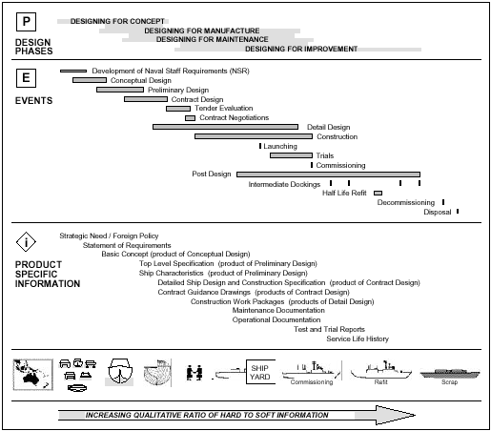
Bras, B. A. and Mistree, F., "Designing Design Processes in Decision-Based Concurrent Engineering," SAE Transactions, Journal of Materials & Manufacturing, vol. 100, pp. 451-458, 1991.

BASIC DSPT ICONS:

Sample Diagram

